**STUDENT MANAGEMENT SYSTEM**

**PROJECT**



Spring 2022

CSE-102L COMPUTER PROGRAMMING LAB

**Group Members**

Submitted by: MUHAMMAD SADEEQ

Registration No.: 21PWCSE2028

Submitted by: WASEEM SAJJAD

Registration No.: 21PWCSE2068

"On my honor, as student of University of Engineering and Technology, I have neither given nor received unauthorized assistance on this academic work.'

Submitted to:

Engr. Abdullah Hamid

(27 July 2022)

Department of Computer Systems Engineering University of Engineering and Technology, Peshawar

**STUDENT MANAGEMENT SYSTEM**

**PROJECT**

* **Description:**

Student Management System is a simple C++ program designed for educational institutions to manage student data and a variety of other student-related data needs. The user can build, show, search, and modify student data in this Student Management System project.

A Student Information System is another name for a Student Management System (SIS). These technologies let faculty members plan their schedules and communicate with one another about students. This approach was created to make data tracking easier for both parents and administrative personnel.

## Objective:

## The Student Management System’s major goal is to keep track of Profiles, Courses, Logins, Exams, and Fees. It keeps track of all information pertaining to Profiles, Students, Fees, and Profiles. Because the project is entirely constructed at the administrative level, only the administrator has access.

## Topics Used From Course:

## Data structure

## Functions

## Arrays

## Variables

## Loops

## If-else statement

## Switch statement

## Features of Student Management System:

## Storage of student data:

## This feature enables us to enter students’ data and store it in the program. e.g. name, roll number, course semester, etc.

## Show data on the screen

## This feature enables us to display all the stored data in the program

## Search for data

## This feature enables us to search data of specific students by entering the roll number of a specific student

## Update data

## This feature enables us to update or make changes in the existing stored data of a specific student in the program

## Delete data

## This feature enables us to delete all the stored data in the program or delete data of a specific student by entering the roll number of that student

## Calculating student fee

## This program has the ability to calculate student fee according to selected department, HSSC percentage, and self-finance (yes or no)

## 

* **Project Code:**

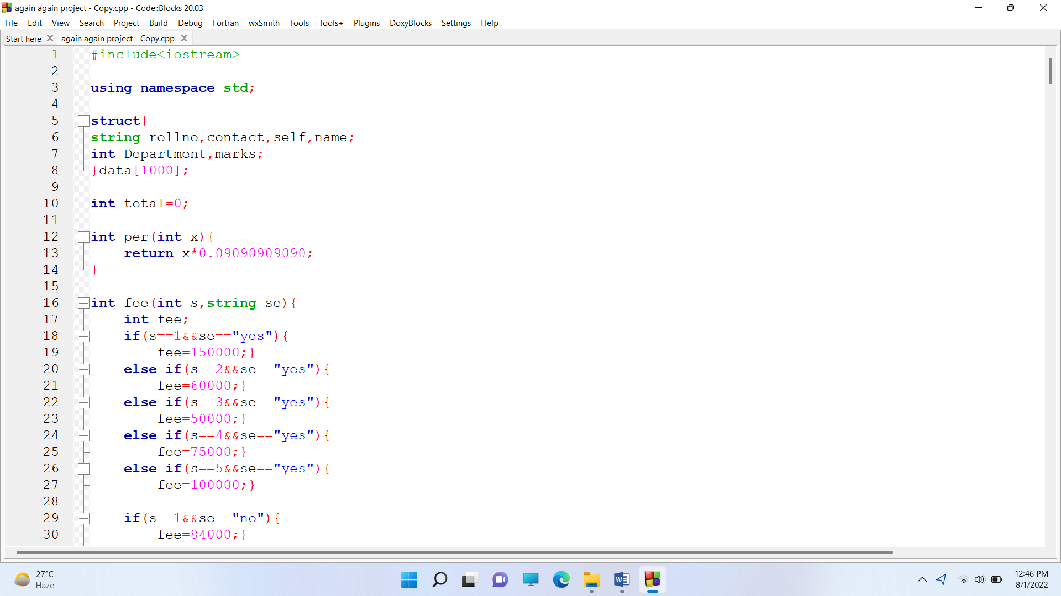

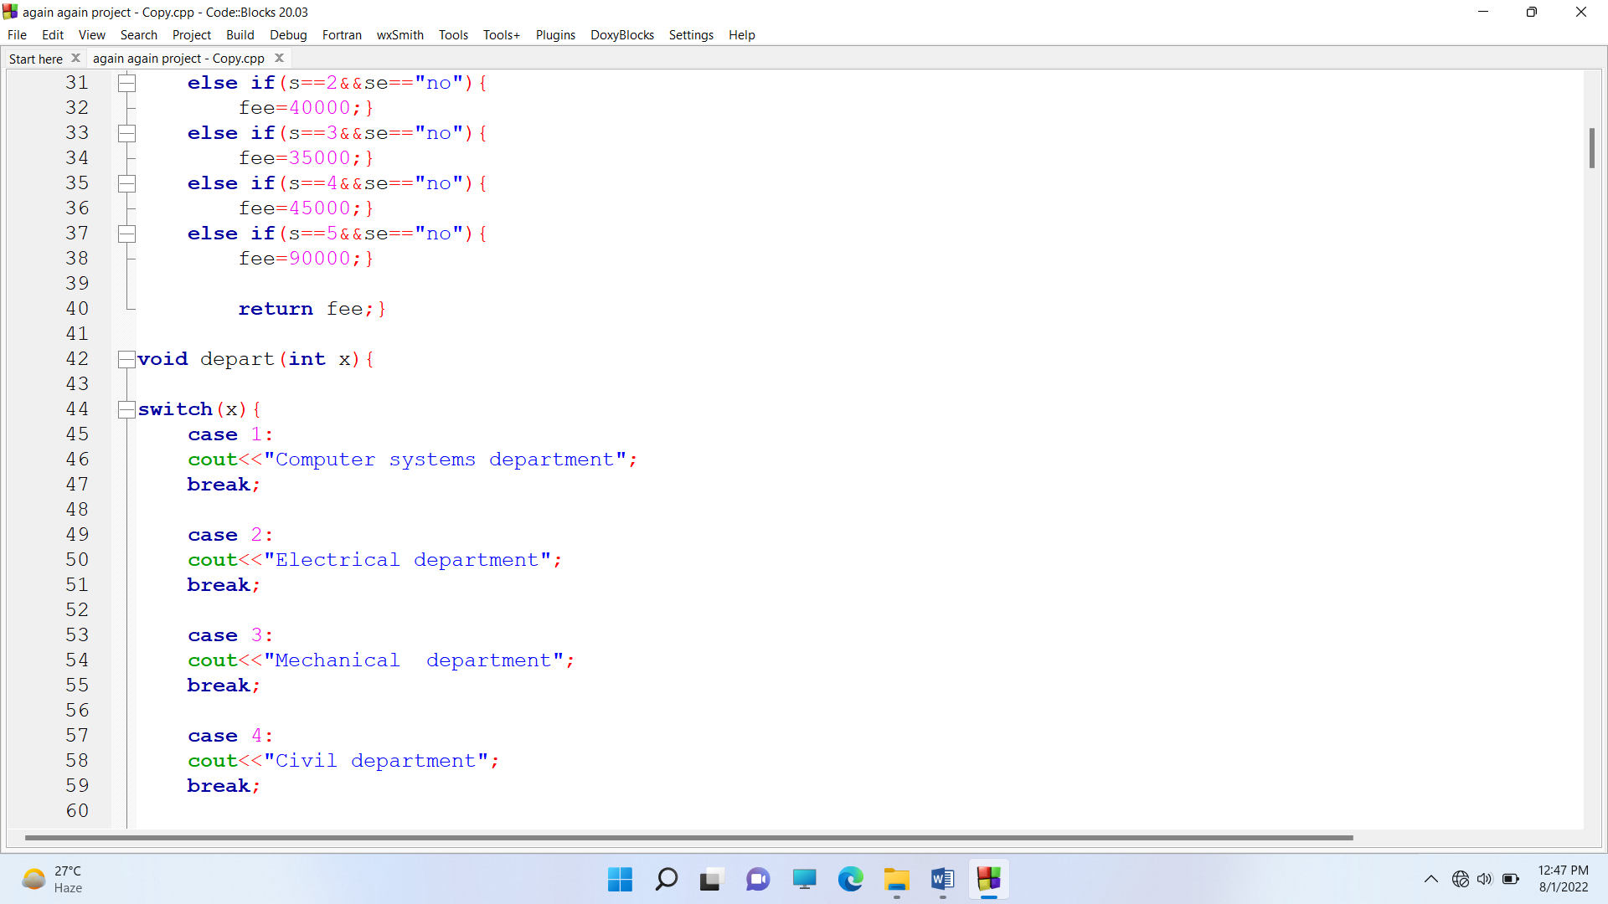

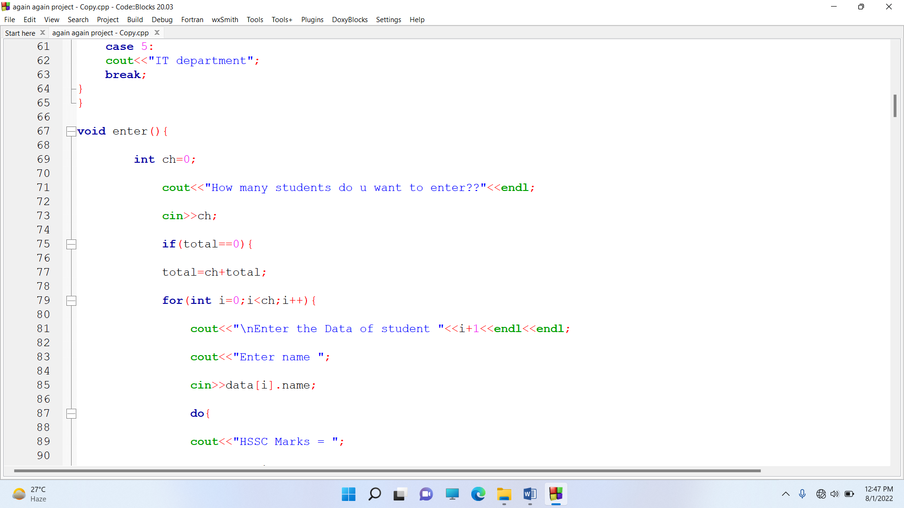

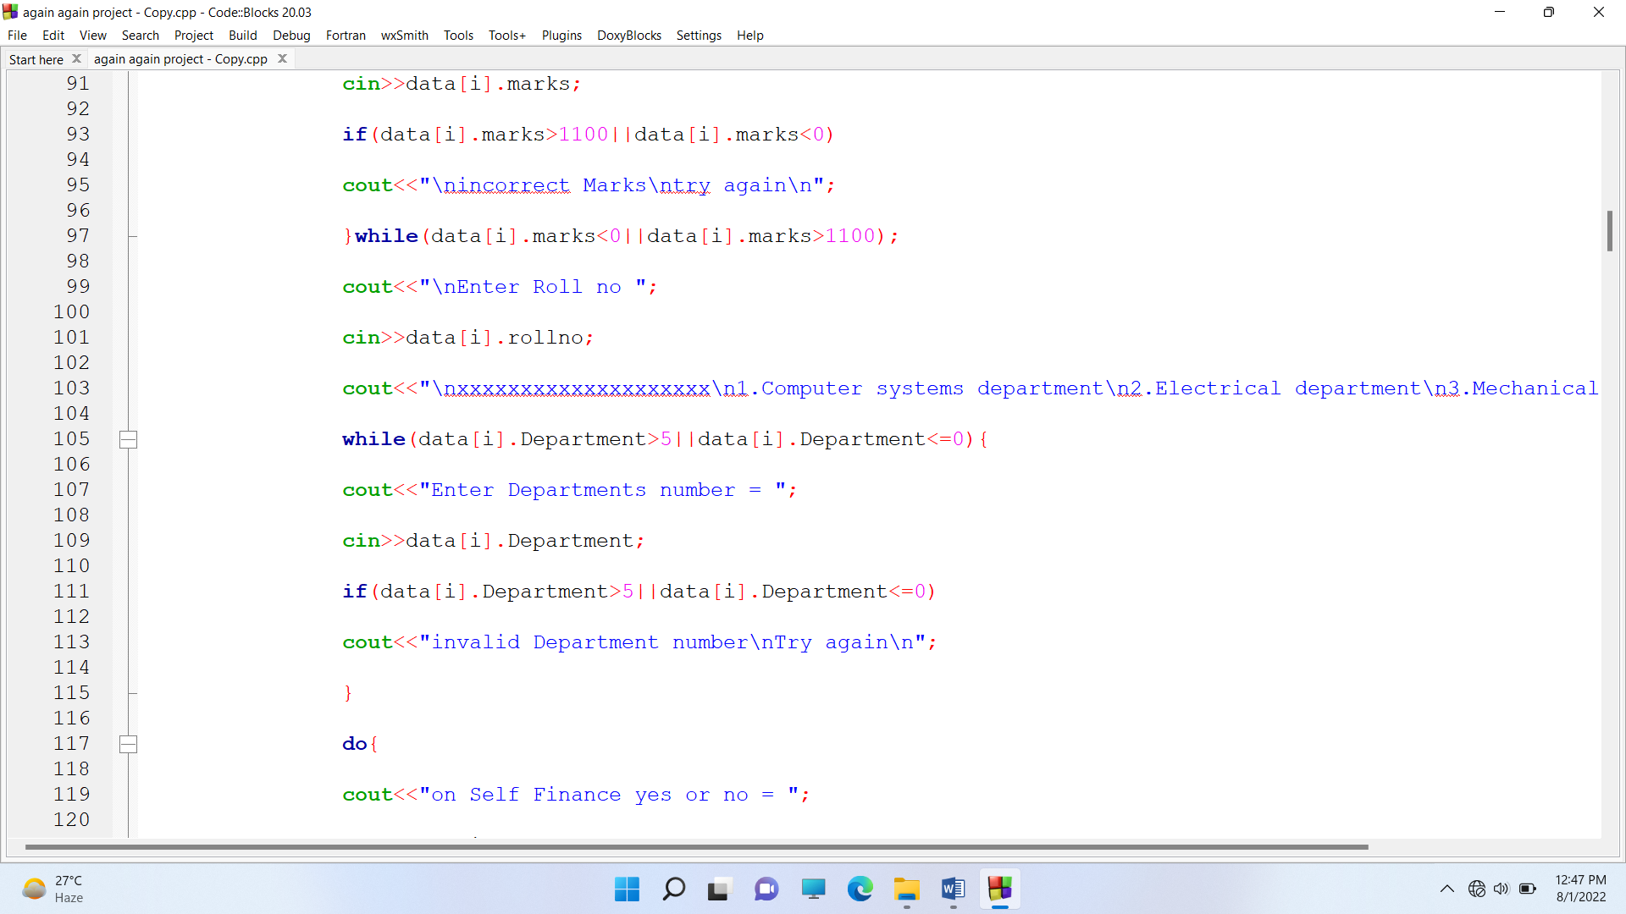

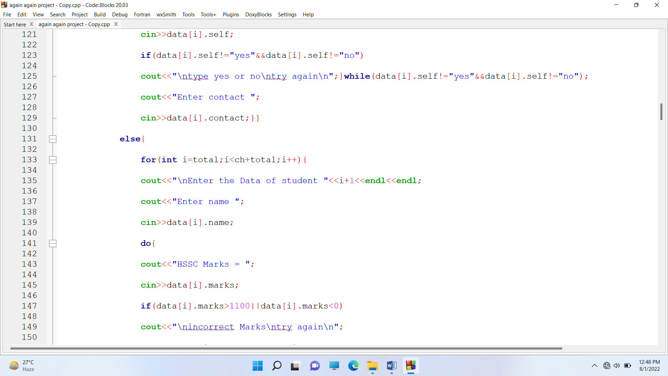

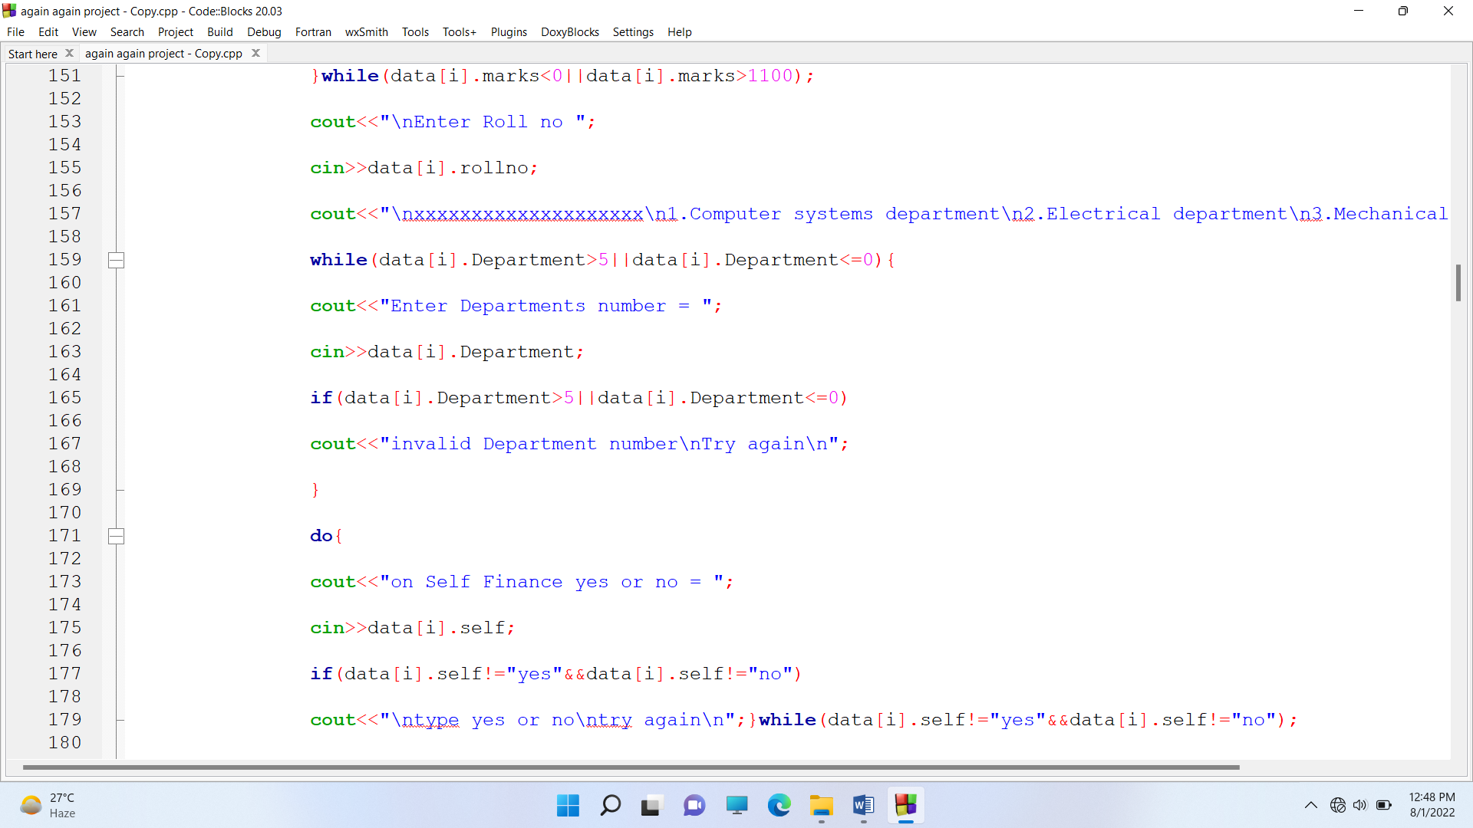

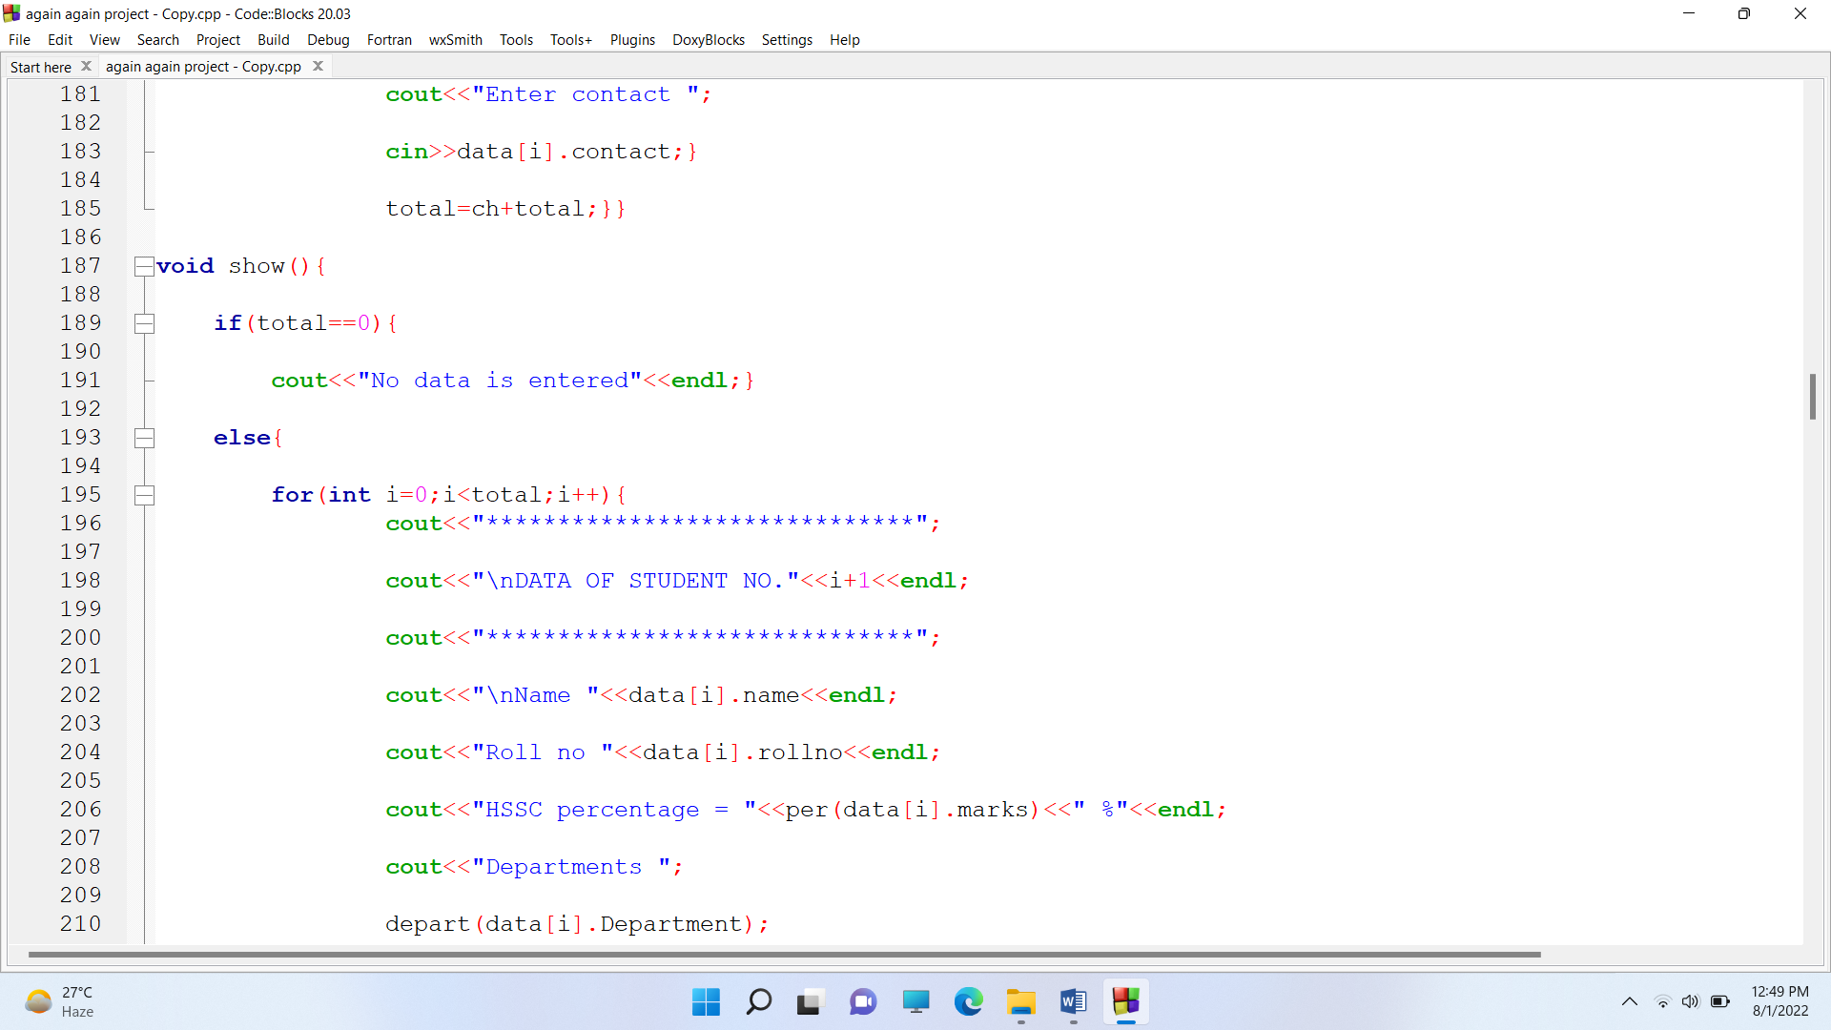

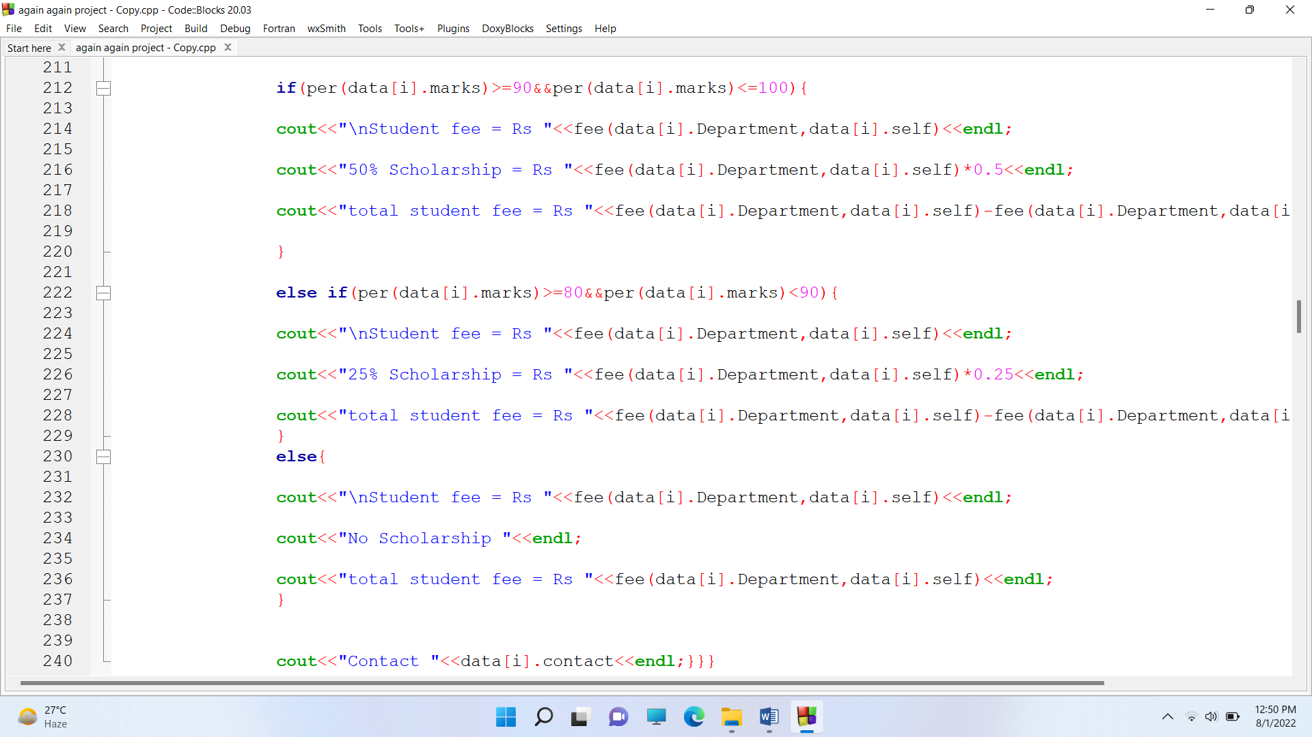

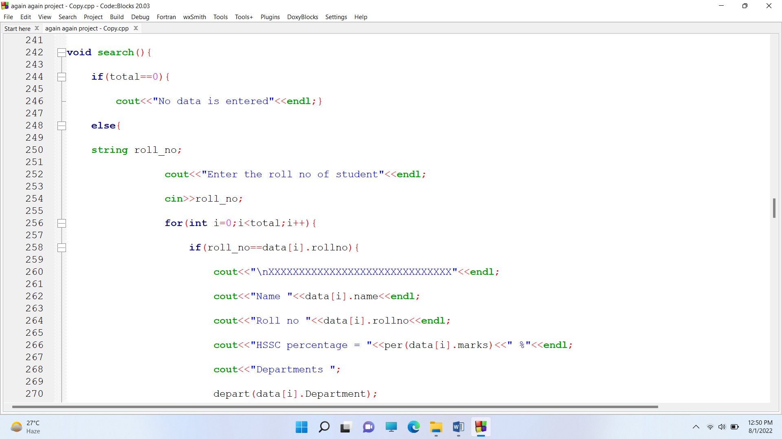

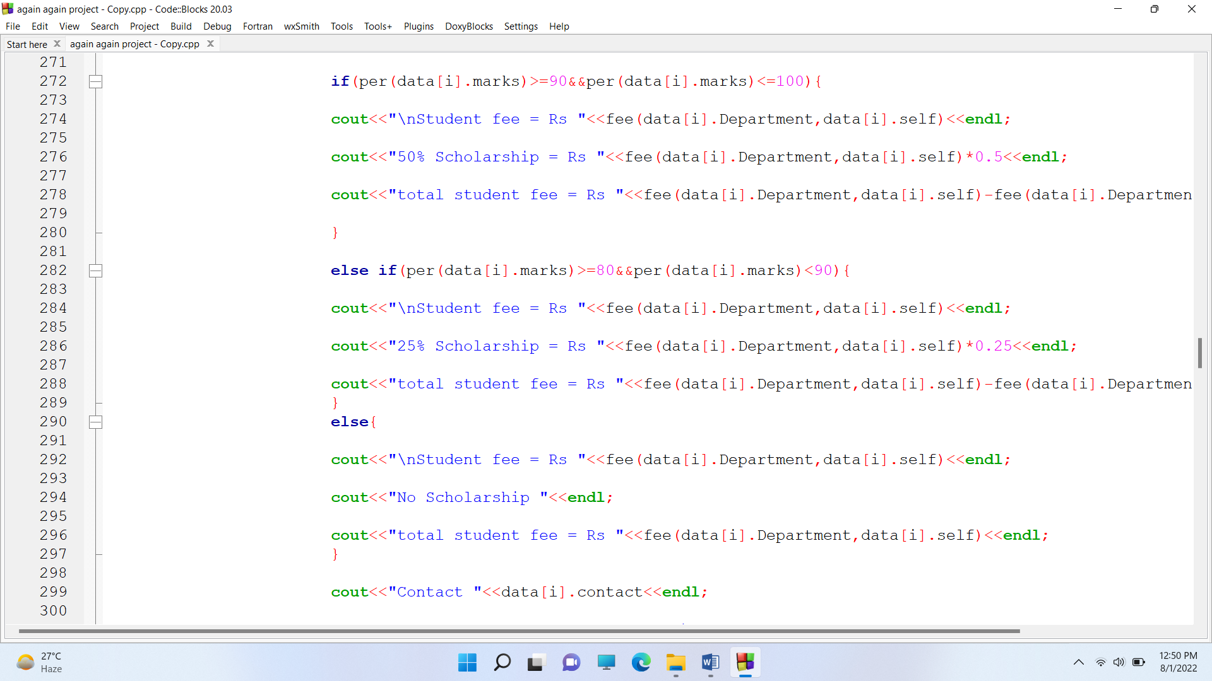

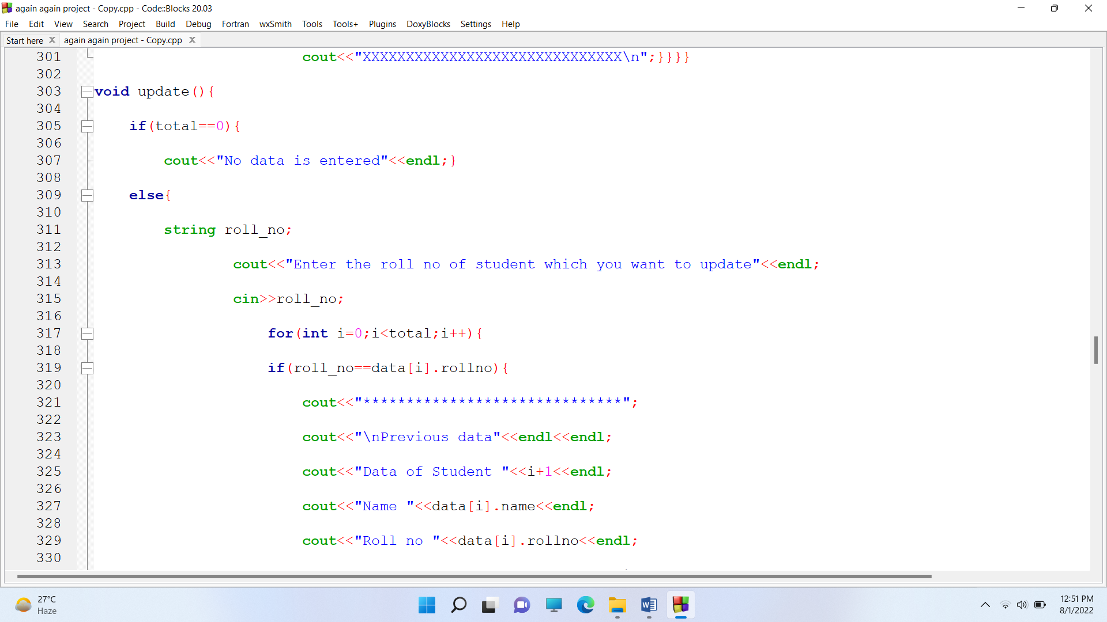

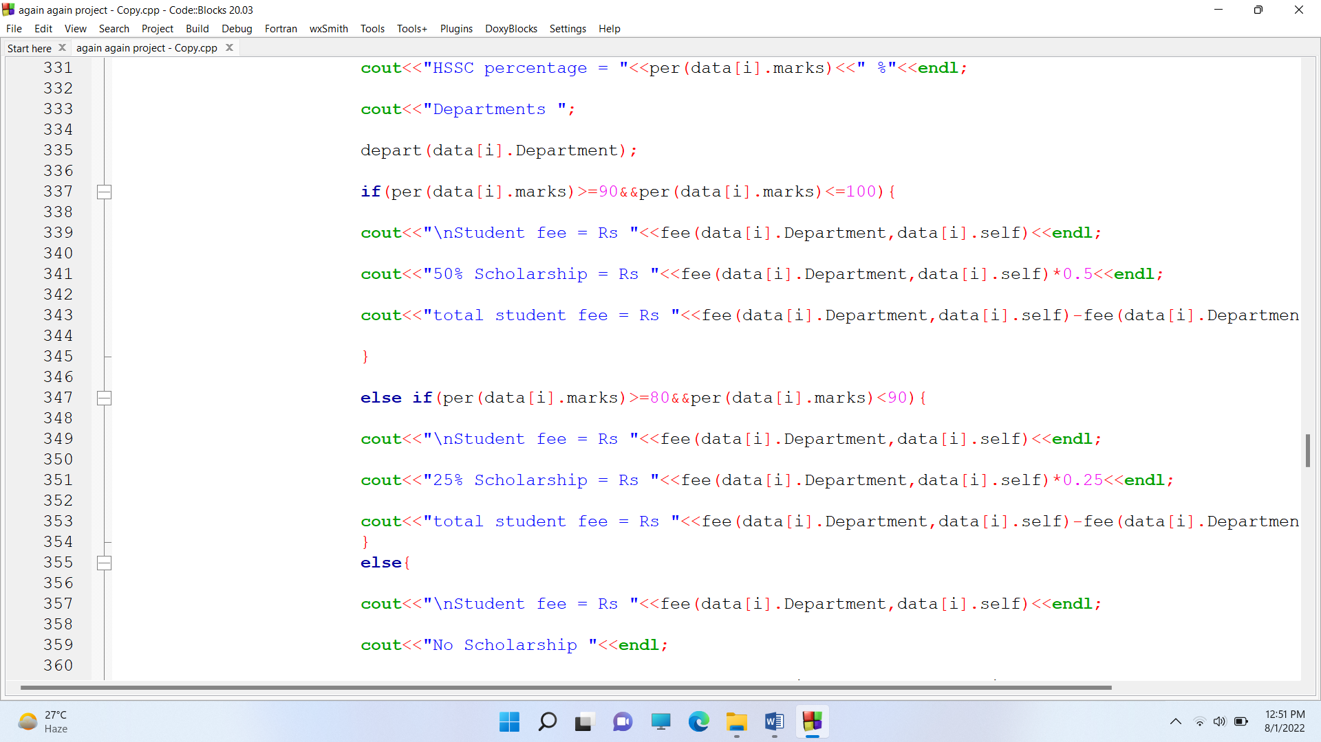

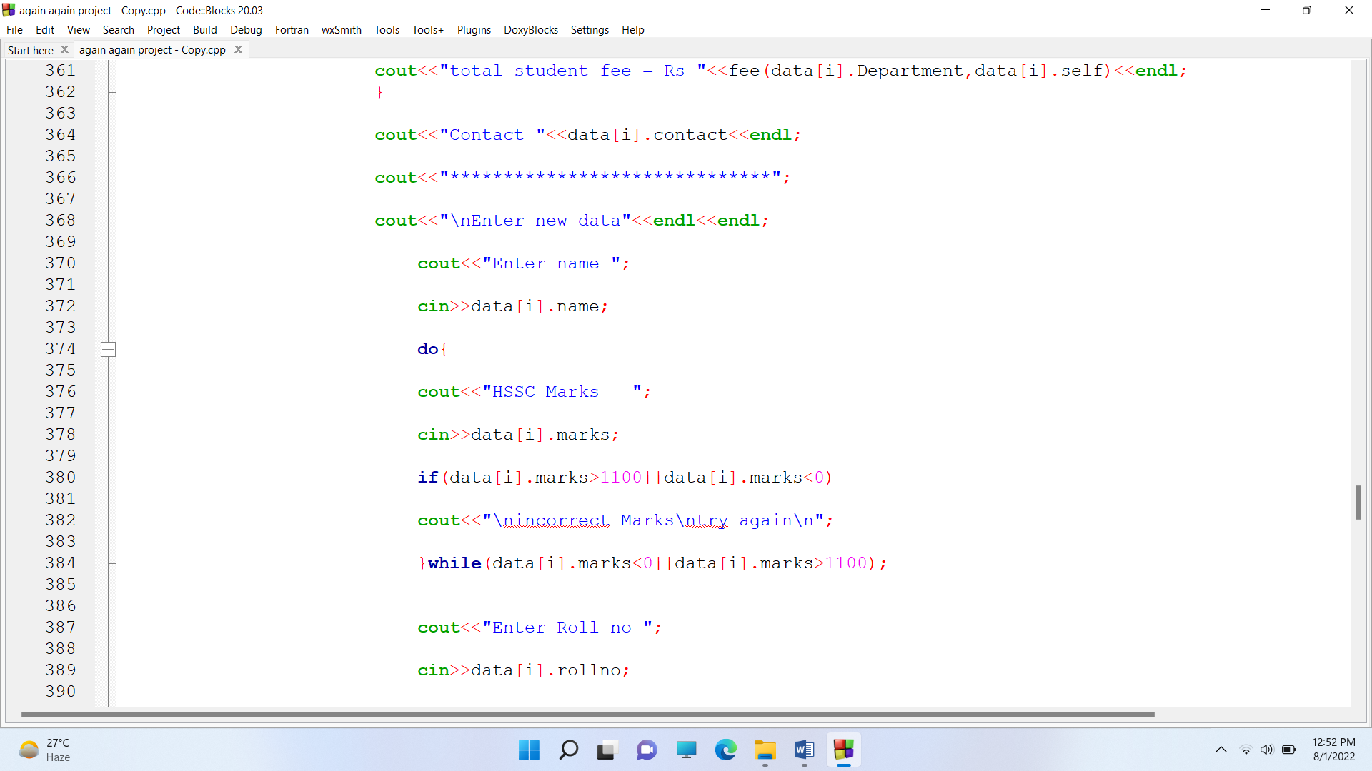

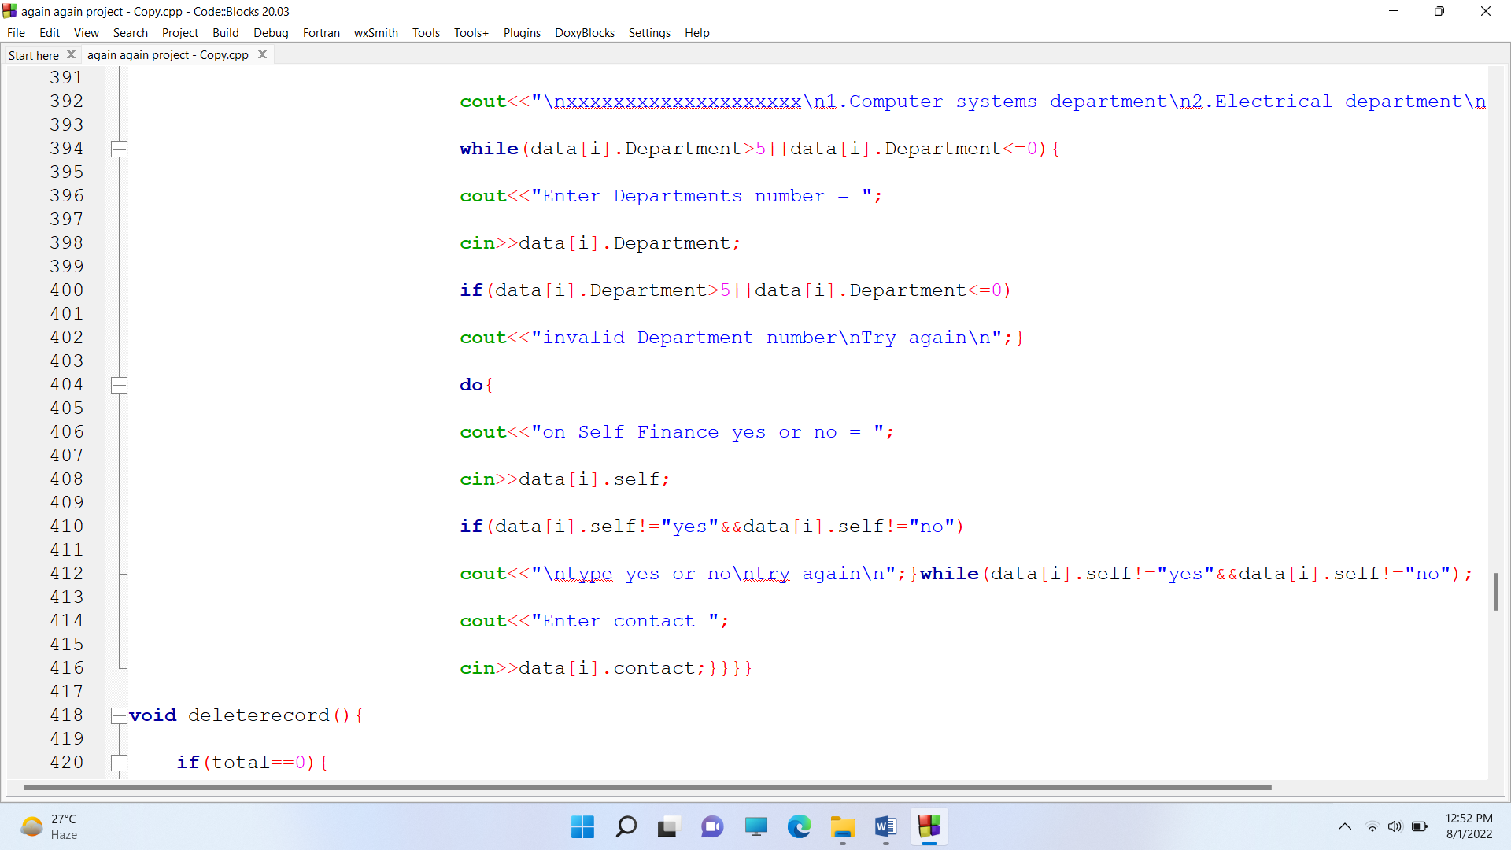

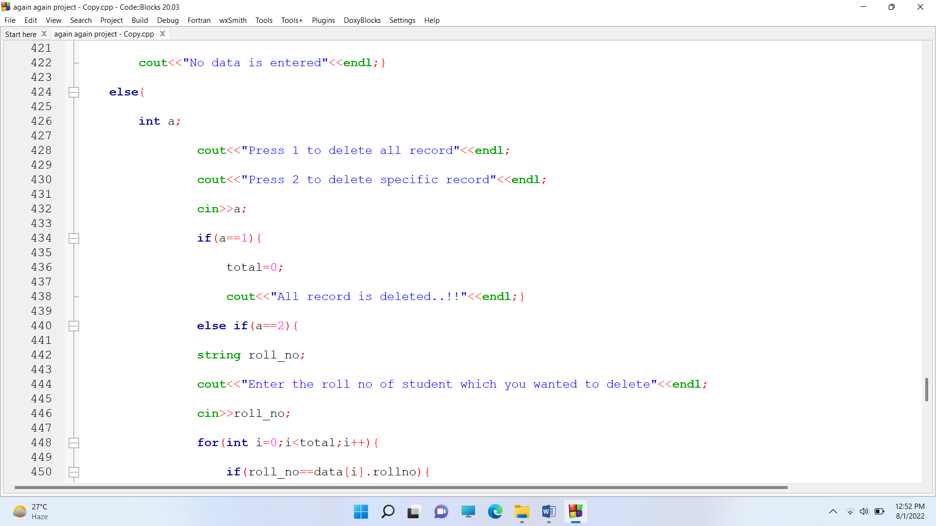

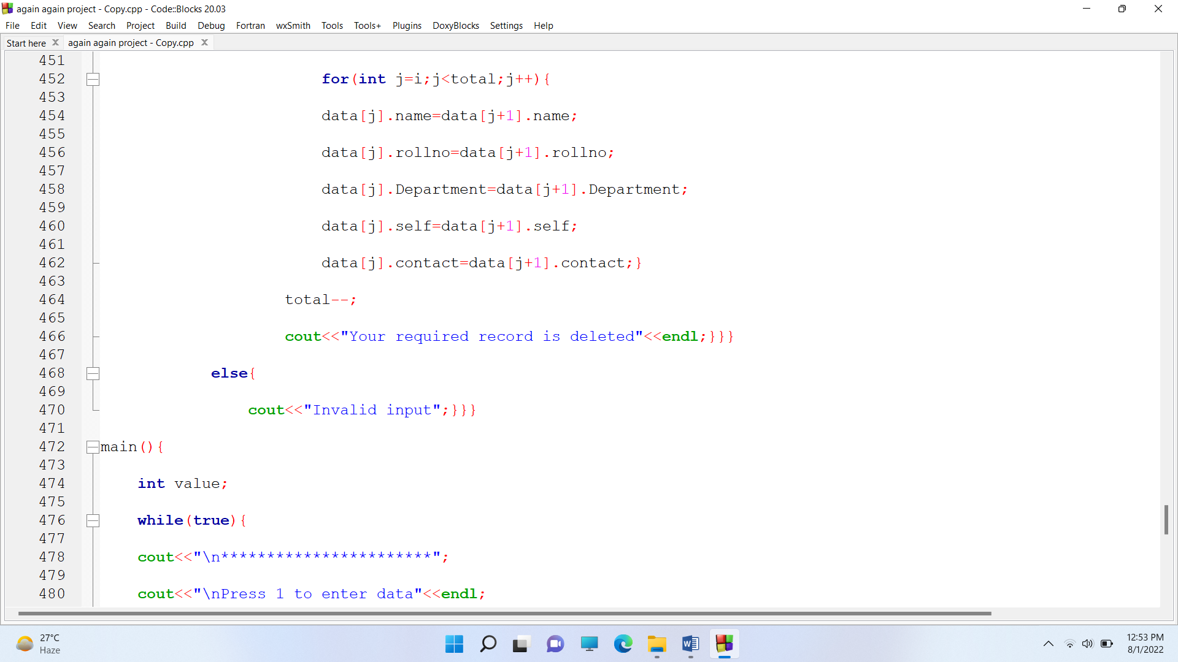

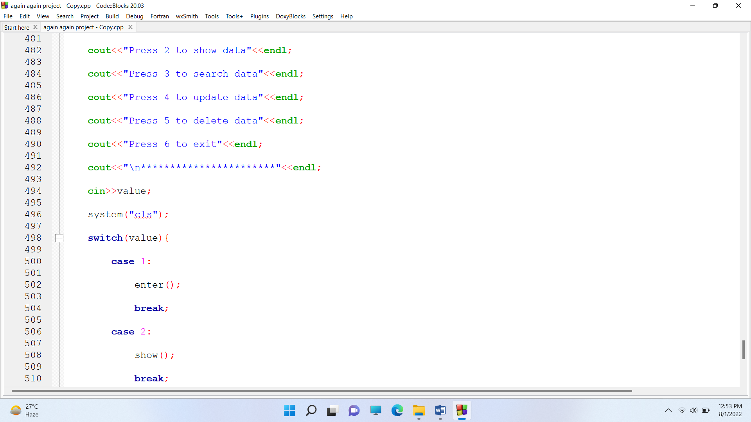

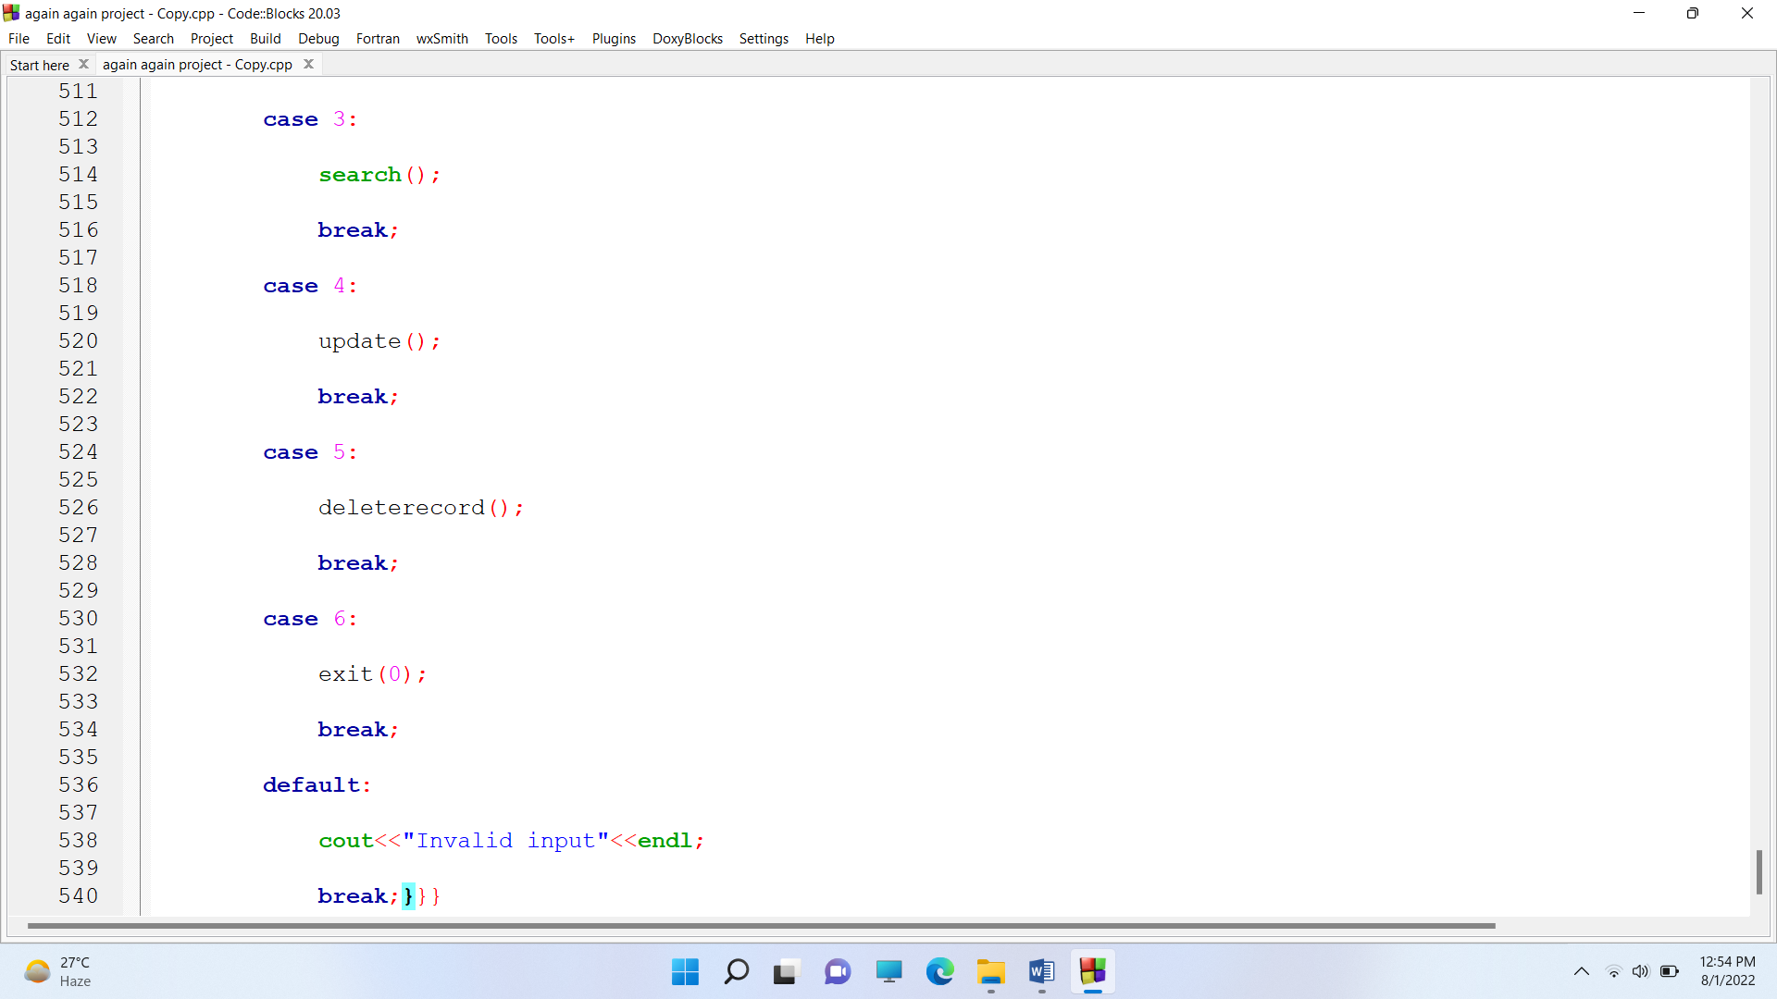

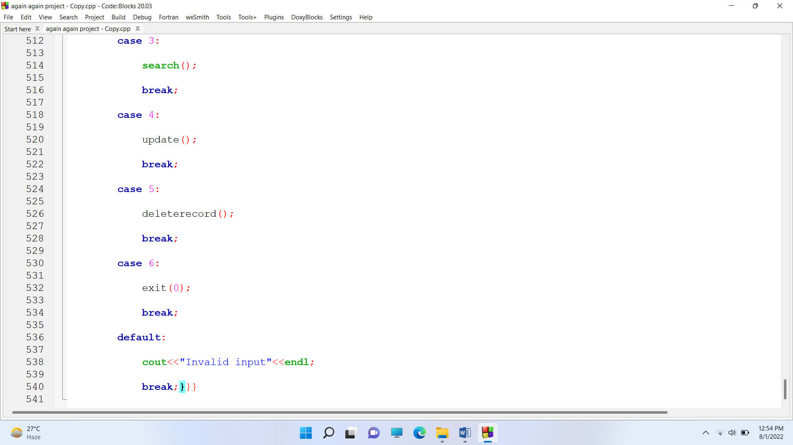

* **Project Output:**

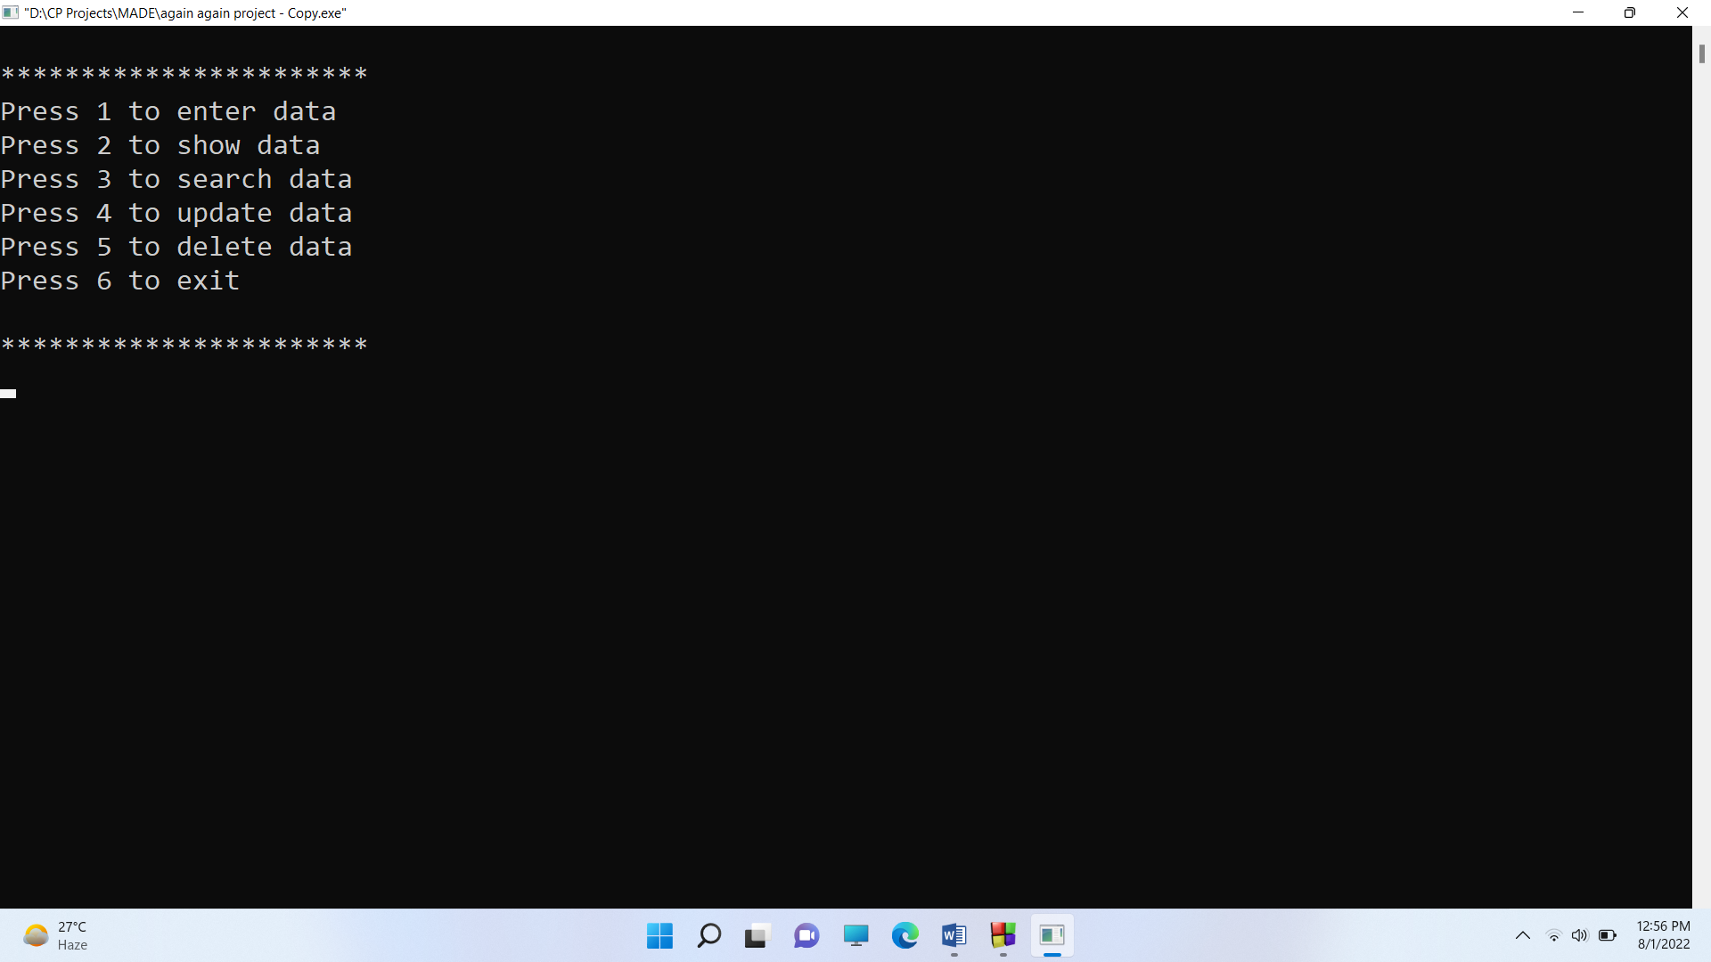

**Entering data**

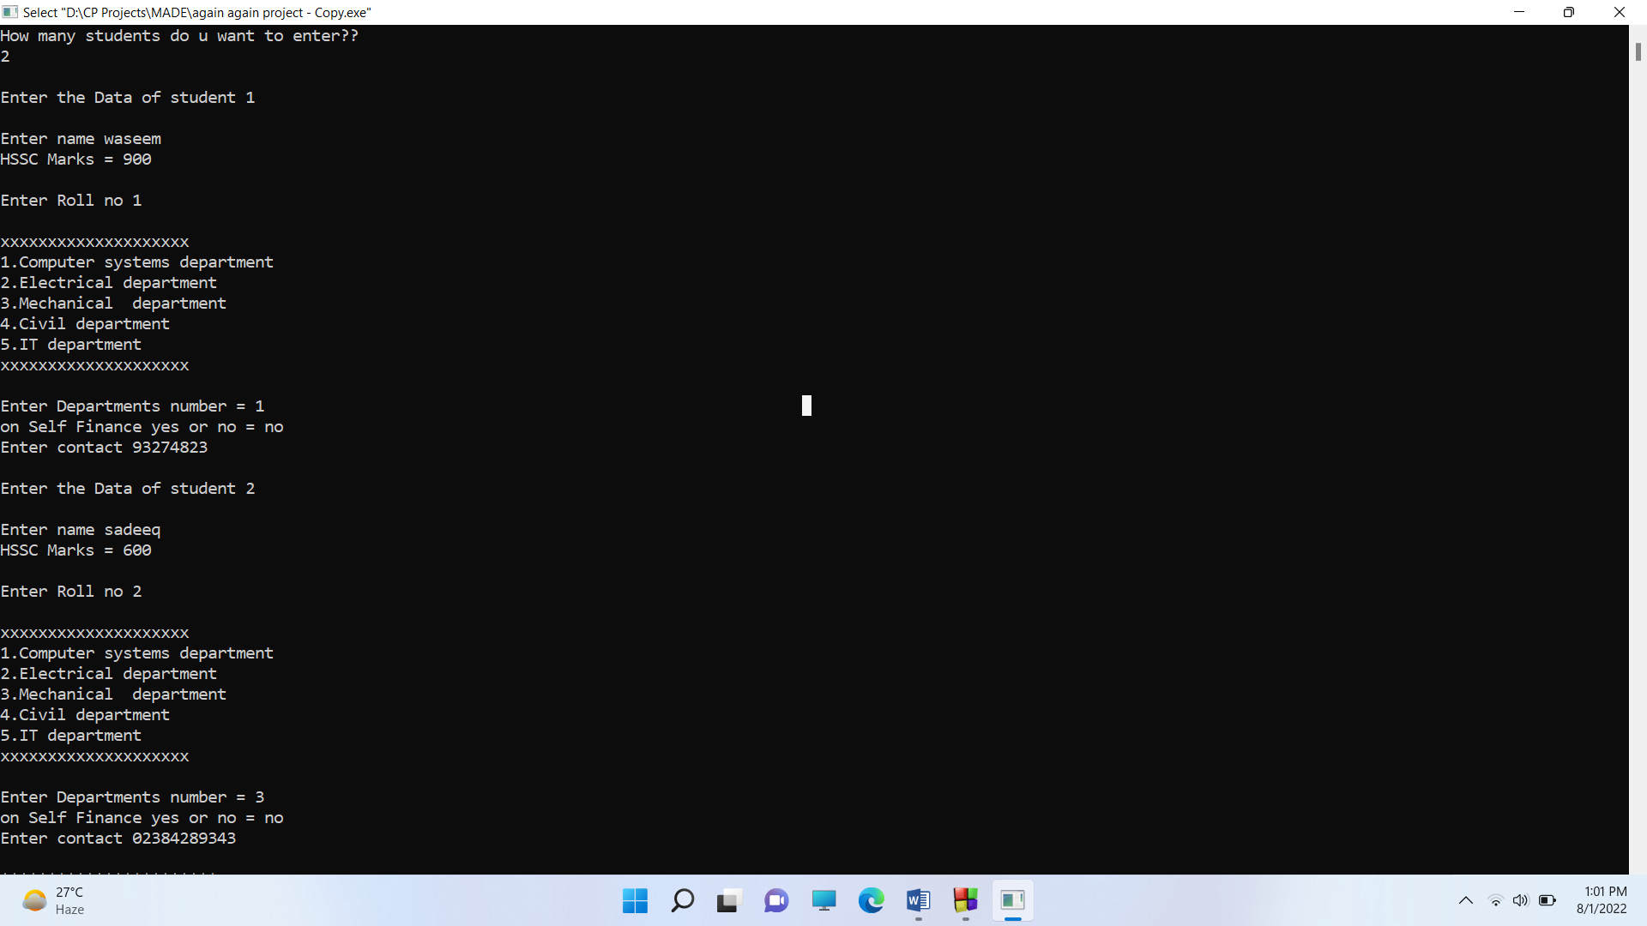

**Displaying data**

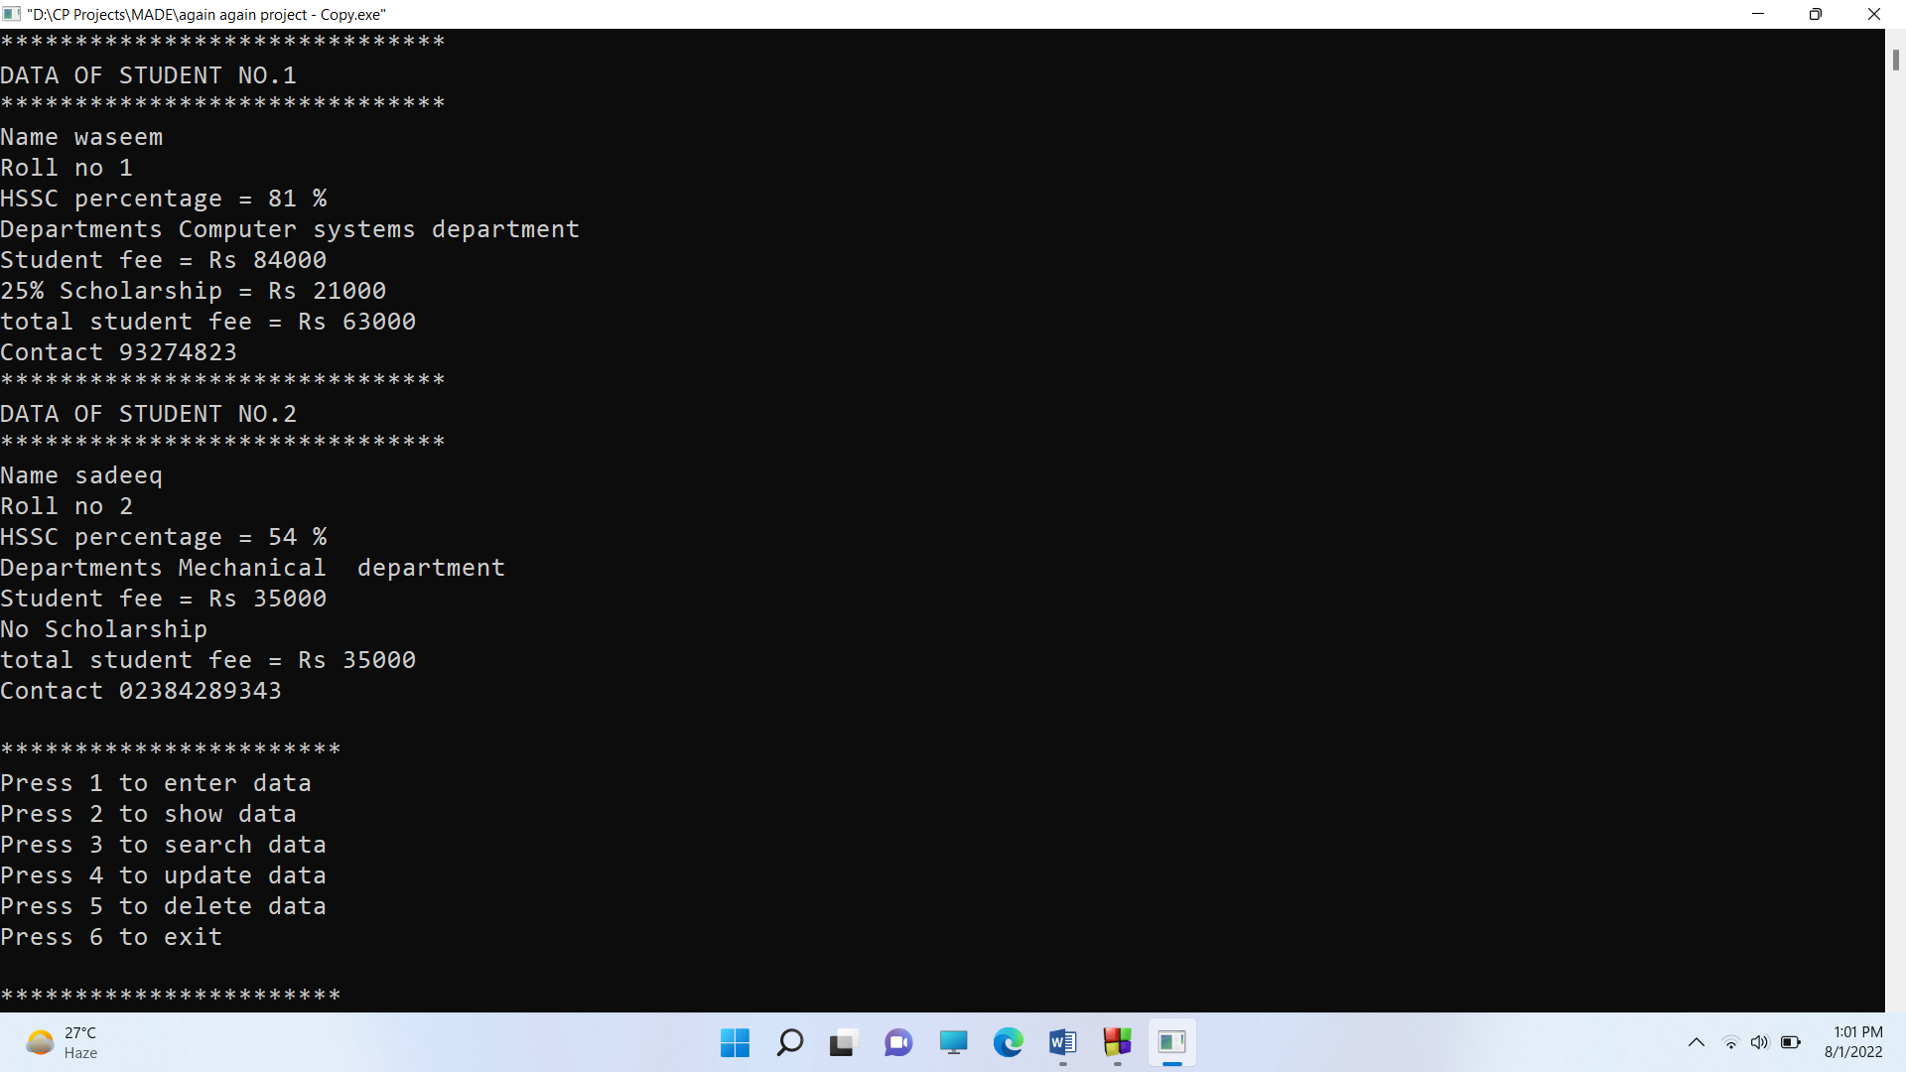

**Searching data**

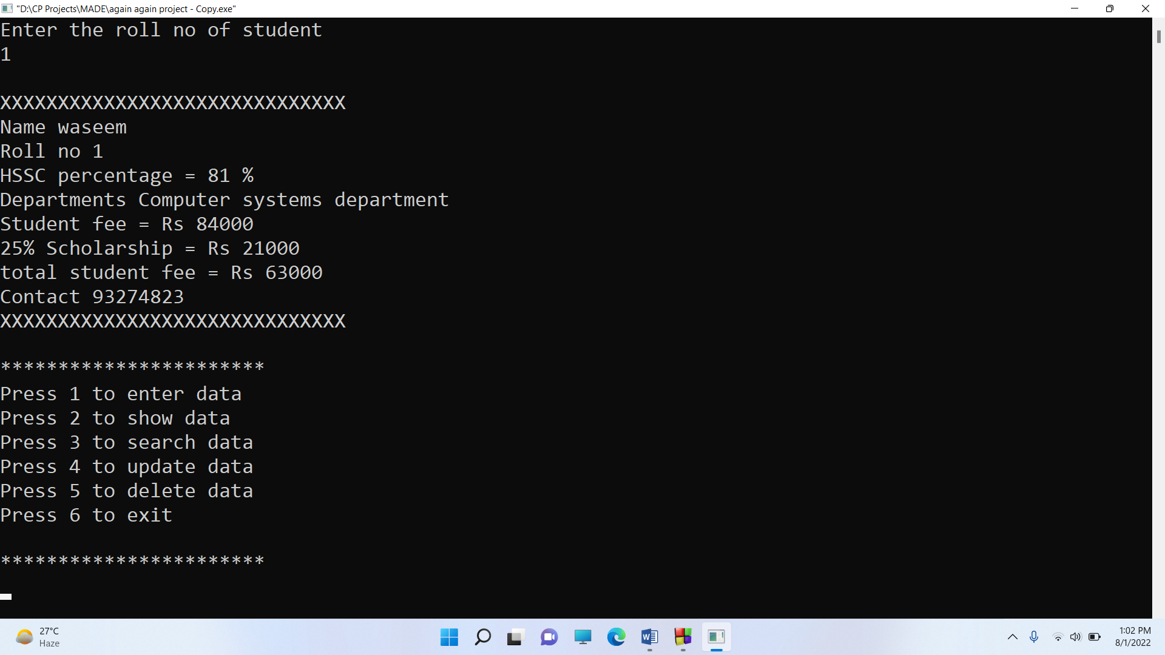

**Updating student data**

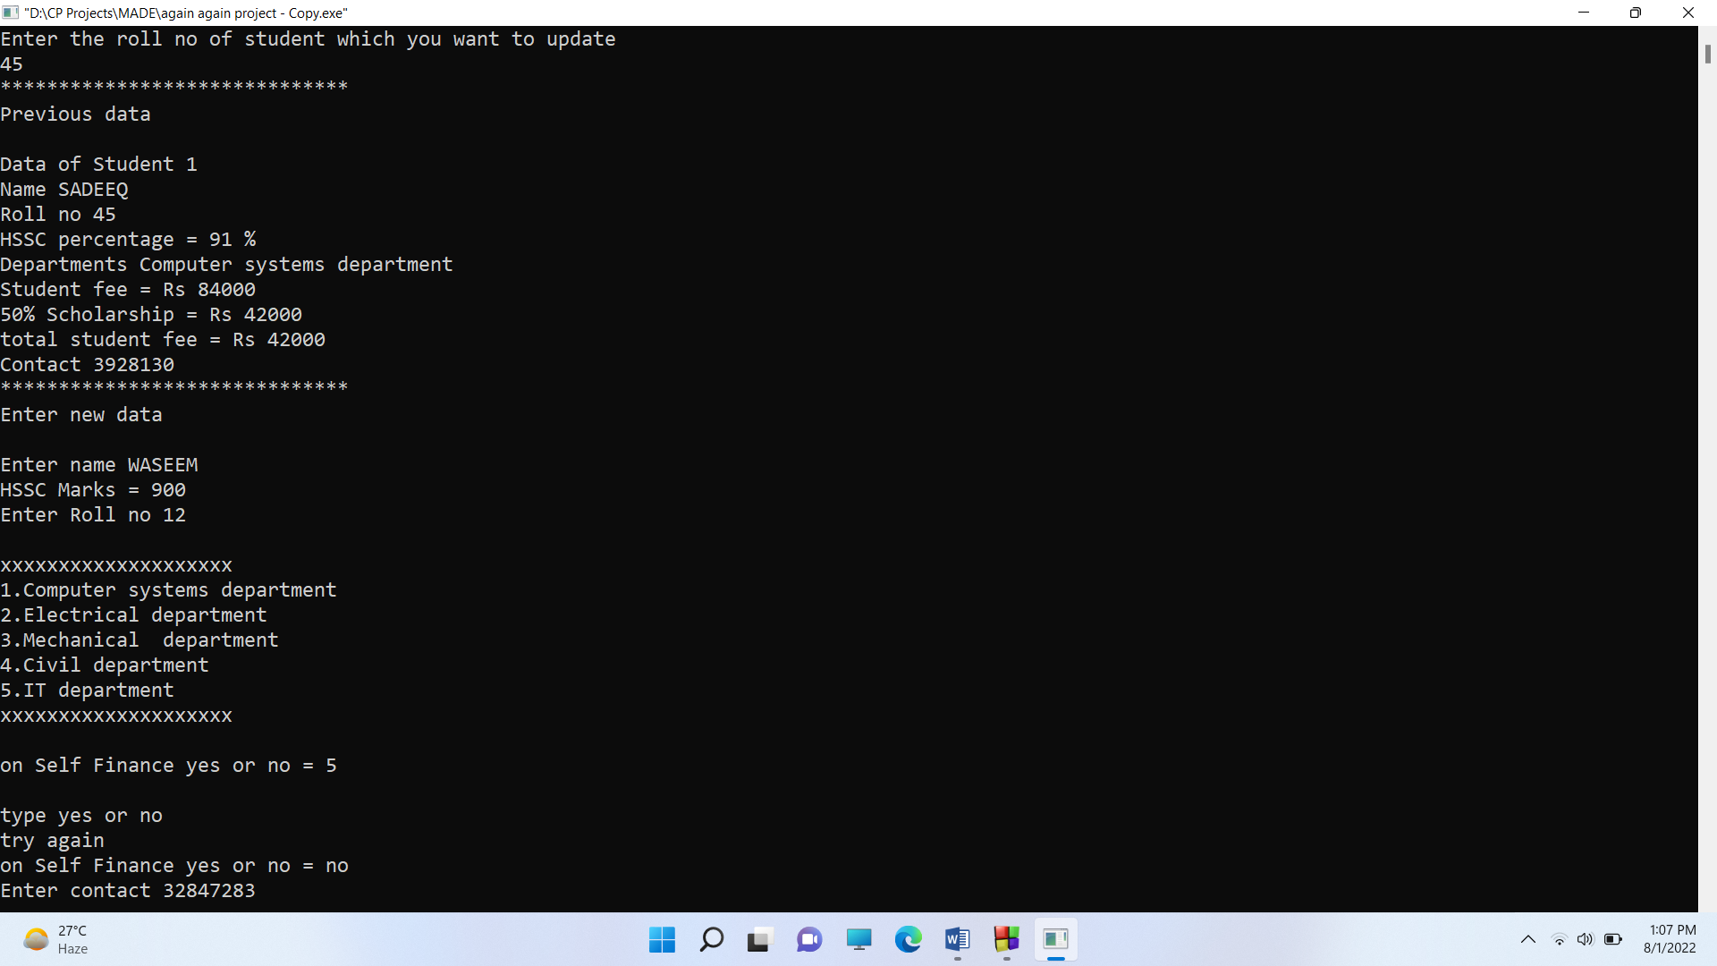

**Deleting data**

